**To Sim or Not To Sim:**

**Computing Budget Allocation in Simulation-Based Policy Optimization**

**Time: 2014-5-26 10:00-11:00 Room: N202**

**Abstract:** Advances in computing technology now allow us to simulate more and more systems with dynamics that can hardly be described by closed-form equations. This is especially true for many large scale networked systems such as remanufacturing, wireless sensor network, smart grid, and smart buildings. In order to find a good (not even the optimal) policy to govern the dynamics of these systems, one has to explore the exponentially exploding policy space using noisy and time-consuming simulation. Therefore it is of great practical interest to study how to efficiently allocate the computing budget so that a good policy can be found within a reasonable period of time. In this talk, we will show the optimal computing budget allocation for policy improvement and discuss its variants when the simulation time is stochastic and when the sample path can be reused. Applications in remanufacturing, wireless sensor network, and smart buildings will be shown.

Speaker:

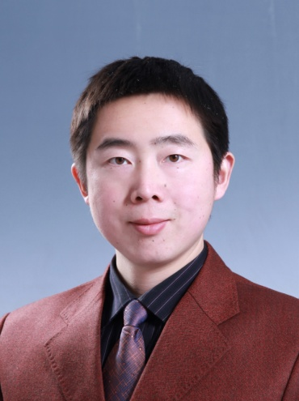

(Samuel) Qing-Shan Jia received the B.E. degree in automation in July 2002 and the Ph.D. degree in control science and engineering in July 2006, both from Tsinghua University, Beijing, China. He is an Associate Professor in the Center for Intelligent and Networked Systems (CFINS), Department of Automation, Tsinghua University. He was a visiting scholar at Harvard University in 2006, at the Hong Kong University of Science and Technology in 2010, and at Laboratory for Information and Decision Systems, Massachusetts Institute of Technology in 2013. His research interests include theories and applications of discrete event dynamic systems (DEDS’s) and simulation-based performance evaluation and optimization of complex systems. He is an associate editor of IEEE Transactions on Automation Science and Engineering, and Discrete Event Dynamic Systems – Theory and Applications. He now serves the Discrete Event Systems Technical Committee chair in IEEE Control Systems Society, and the Smart Buildings Technical Committee co-chair in IEEE Robotics and Automation Society. He is also chairing the IEEE Control Systems Society Beijing Chapter.